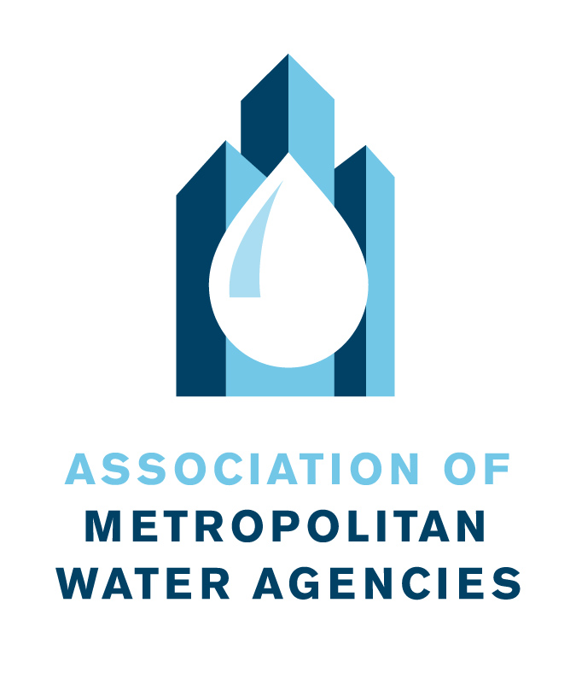
Make the Most of Your Membership

AMWA provides a wide range of services to our member agencies. However, we find that many of our members are not taking full advantage of your membership. Following are ways you can ensure that you are making the most of your AMWA membership:

Connect with other leaders in the industry
Members consistently rank AMWA’s strong peer network as one of our top benefits. AMWA creates opportunities for nearly 200 utility executives to build relationships, exchange ideas, and learn from other water utility leaders. AMWA’s conferences and events allow members exclusive interaction with key legislators and provide opportunities to learn from sector leaders through our Water Policy Conference and Executive Management Conference.

Engage your team
Did you know that all your employees are eligible to receive AMWA benefits? Simply send a list of your colleagues, their titles, and their email addresses to Info@AMWA.net, or request a form to provide additional information to AMWA to better serve you and your team.

To keep them and you informed:
- The Monday Morning Briefing weekly covers the latest public policy issues affecting the water industry; legislation affecting large water utilities; AMWA’s work on Capitol Hill; and news about AMWA meetings and convenings, resources, and more.
- The monthly Water Utility Executive provides perspectives on management issues and highlights events and resources relevant to water system management and leadership.
- The AMWA website, from policy white papers to Member-to-Member Inquiries, provides a wealth of information.

You can also engage your team on our committees. They can grow in their issue expertise and leadership skills by collaborating with other experts in the industry on a variety of issues and subject areas.

Dive into our educational materials
AMWA brings water executives the news and information they need to operate optimally.
- INSIGHT, a database of utility financial information allows participating members to compare their data to that of other utilities. Members can also use findings to effectively identify trends and better understand the financial dynamics of peer utilities across the country.
- Member-to-Member Inquiries offer an effective way for members to share knowledge and experience through short, quick-turnaround surveys on topics such as facilities security, advanced meter infrastructure, and customer assistance programs.
- The Water and Wastewater Leadership Center, a 12-day executive training program where water utility leaders hone their management skills and further develop their leadership style, conducted as a joint venture with top water sector organizations.
- Briefings and white papers on everything from financial data to legislative and regulatory policy can be accessed through the Members-only section of the website.

Gain National Recognition
AMWA annually recognizes the extraordinary management programs and stellar workforce performance of our utility members and leadership through our utility management awards program, which honors members with the Gold Award for Exceptional Utility Performance, the Platinum Award for Utility Excellence, or the Sustainable Water Utility Management Award. Distinguished panels of peer judges evaluate award applicants. AMWA also honors individual accomplishments in the sector through the President’s Award and Donald R. Boyd Award.

Take Advantage of AMWA’s Utility Sustainability Resources…
AMWA provides members with information and opportunities for sharing in support of resilient, sustainable utilities. The association tackles subjects such as utility innovation, environmental justice, climate adaption and financial resilience. AMWA reports have covered topics such as heat impacts to infrastructure and employees, credit ratings and bond market interests in municipal water utilities, and green bonds. Utility resilience and climate adaptation have been the topics of events organized by AMWA in collaboration with other sector organizations. With input from members, AMWA advocates for federal policy and programs that support innovative, cross-sector solutions to climate preparedness and resilience.

… and Its Utility Security Resources
To help water utilities address threats from intentional contamination, terrorism, and cybercrime, AMWA helps shape national policy on both cyber and physical critical infrastructure protection and helps protect its members’ security by engaging with the Department of Homeland Security, EPA, and other federal infrastructure protection agencies. Timely publications and webinars cover topics such as utility responses to the coronavirus pandemic, the emerging threat of disinformation aimed at the water sector and how to address it, and risk and resilience assessments. AMWA’s nimble COVID-19 response included an online resource library, webinars for utilities to share best practices, surveys to gather critical information on utility financial impacts, federal lobbying on key issues including designation of water system employees as critical workers and funding to assist low-income water rate payers. In addition, AMWA established WaterISAC, a separate, membership-based network, providing critical water security information to drinking water and wastewater utilities.

Find out more at www.amwa.net and connect with AMWA on Twitter and LinkedIn.

